Colon Cancer
Name
Institution
Date

Colon Cancer
It is a type of cancer affecting the large intestine
It usually starts as polyps, which are tiny, noncancerous (benign) clusters of cells that grow on the inside of the large intestine. Some of these polyps can turn into colon cancer over time.
Due to the small nature of polyps, which makes them causes few symptoms, frequent screening tests are recommended for the prevention of colon cancer through the identification and removal of polyps prior to turning into cancer (Benson et al., 2018).
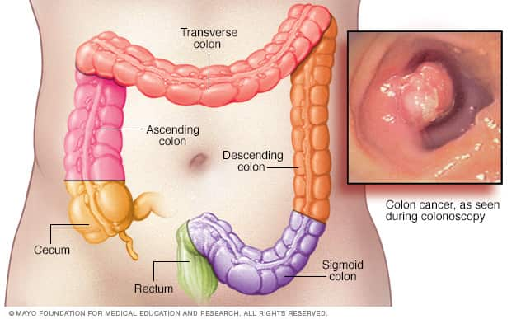
Myths about Colon Cancer
- People have nothing to do to prevent colon cancer development
- Colon cancer is deadly
- Symptomatic people are the only ones supposed to undergo screening
- Colon cancer only gets people with a family history of this condition
- Colon cancer affects older and white men only
- Colonoscopy is a difficult and painful clinical procedure (American Society of Colon & Rectal Surgeons, 2020).
Facts about Colon Cancer
- In 2018, 141 074 new cases of colon cancer were reported (CDC, 2021)
- 52 163 Americans succumbed to colon cancer the same year
- Cancer is the second leading primary cause of death in the US
- Men have a high rate of colon cancer infection compared to females
- Blacks and Hispanics are the ethnic groups with the highest rate of colon cancer infection
To Learn More
American Society of Colon & Rectal Surgeons
https://fascrs.org/patients/diseases-and-conditions/a-z/colon-cancer-myths-vs-reality
Centers for Disease Control and Prevention
https://www.cdc.gov/cancer/colorectal/statistics/index.htm
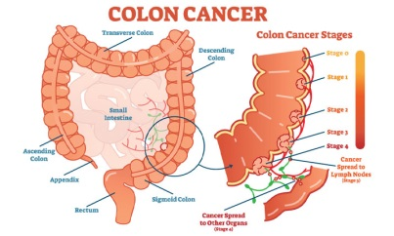

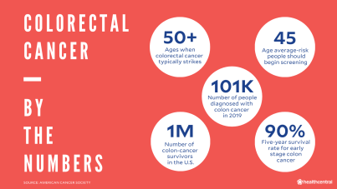
References
American Society of Colon & Rectal Surgeons. (2020). Myths about Colorectal Cancer. Retrieved from https://fascrs.org/patients/diseases-and-conditions/a-z/colon-cancer-myths-vs-reality
Benson, A. B., Venook, A. P., Al-Hawary, M. M., Cederquist, L., Chen, Y. J., Ciombor, K. K., ... & Freedman-Cass, D. A. (2018). NCCN guidelines insights: colon cancer, version 2.2018. Journal of the National Comprehensive Cancer Network, 16(4), 359-369.
CDC. (2021). Colorectal (Colon) Cancer. Retrieved from https://www.cdc.gov/cancer/colorectal/statistics/index.htm
Osterman, E., & Glimelius, B. (2018). Recurrence risk after up-to-date colon cancer staging, surgery, and pathology: analysis of the entire Swedish population. Diseases of the Colon & Rectum, 61(9), 1016-1025.
Signs and Symptoms
- Unexplained loss of weight
- A continuous change in bowel habits like diarrhea and changes in stool consistency
- Continuous discomfort in the abdomen like cramps
- Presence of blood in stool
- Bleeding in the rectum
- A feeling that the bowel does not empty totally (Osterman & Glimelius, 2018)
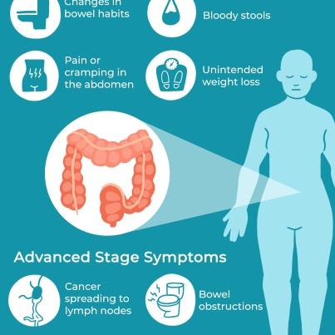
Treatment Modalities
- Surgery- usually, the treatment of colon cancer involves surgical operations. Surgeries include polypectomy, a laparoscopic, partial colectomy, and lymph node removal (Benson et al., 2018).
- Chemotherapy- this involves the use of drugs helpful in destroying cancer cells. It is done after surgery.
- Radiation therapy- involves using X-rays to aid in the killing of cancer cells. It is also helpful in the relief of symptoms like pain.
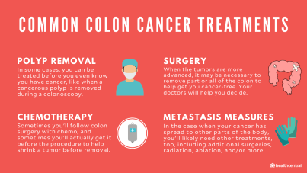
Prevention
Screening
- Individuals with an average risk of developing colon cancer should be screened for colon cancer when they hit 50 years (Benson et al., 2018).
- Individuals with a high risk of colon cancer, including those with a family history of this condition, should be screened at the earliest stages.
Lifestyle Changes
- Consumption of healthy diets like whole grains, fruits, and vegetables
- Avoid alcohol or drink in moderation
- Avoid smoking
- Increase physical activeness
- Maintain a healthy body weight (Benson et al., 2018).
